Birth
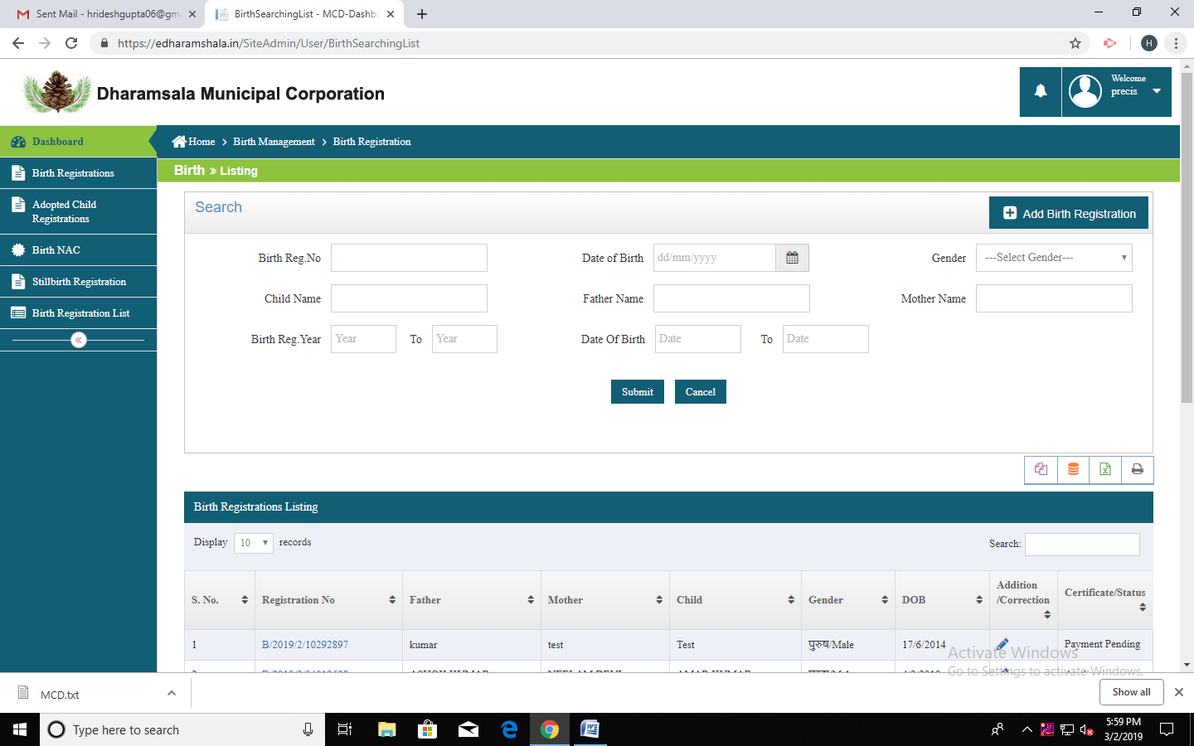
If Registration Date of baby between 21 Day to 31 day date of birth
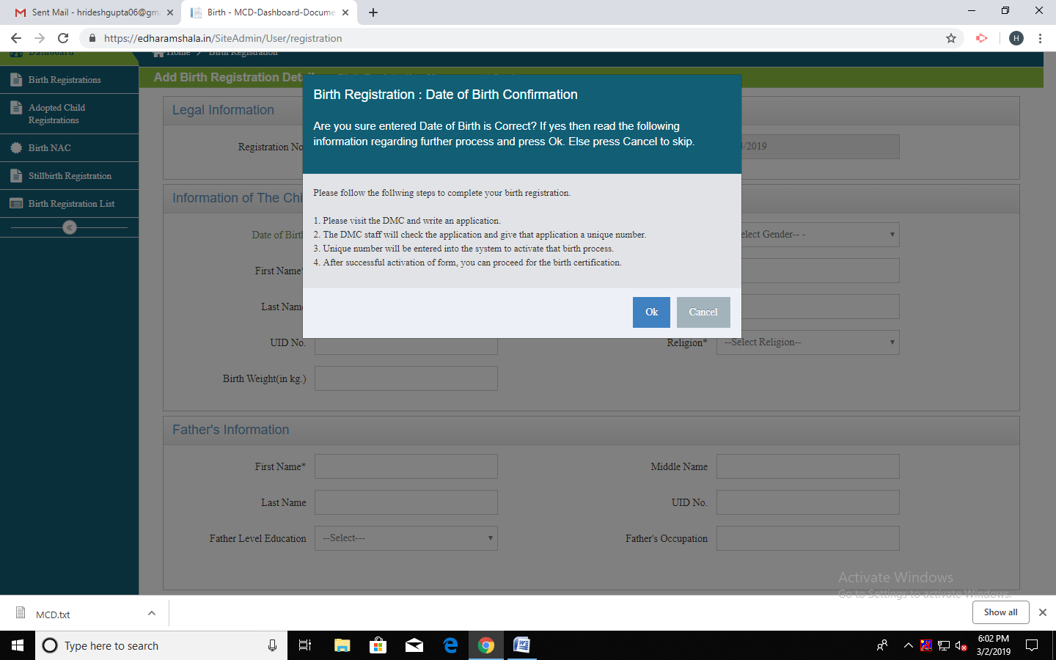
If Registration Date of baby between 31Day to 365 day date of birth

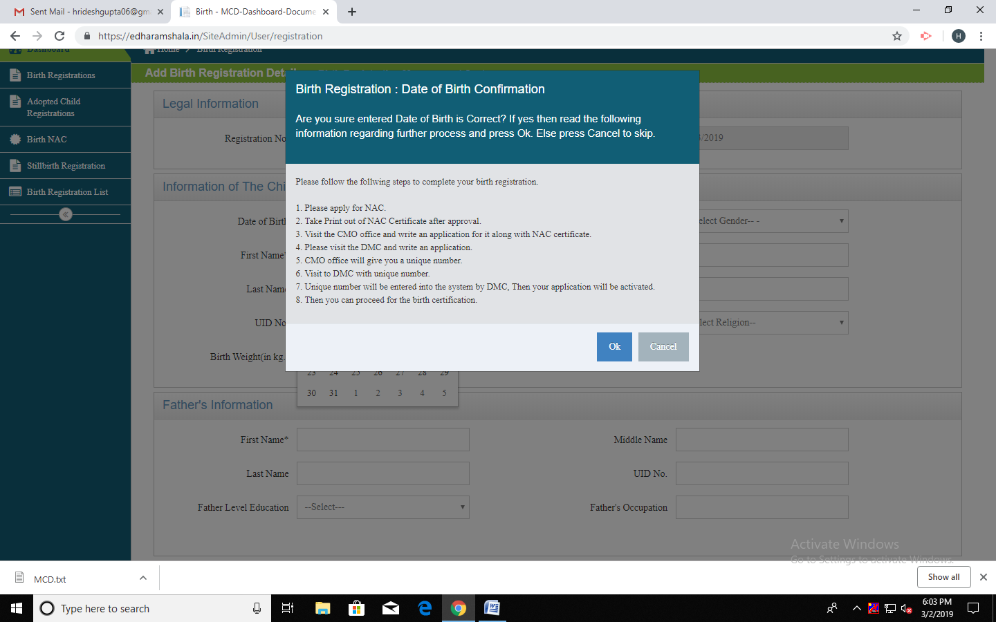

If Registration Date of baby more than 365 days from date of birth
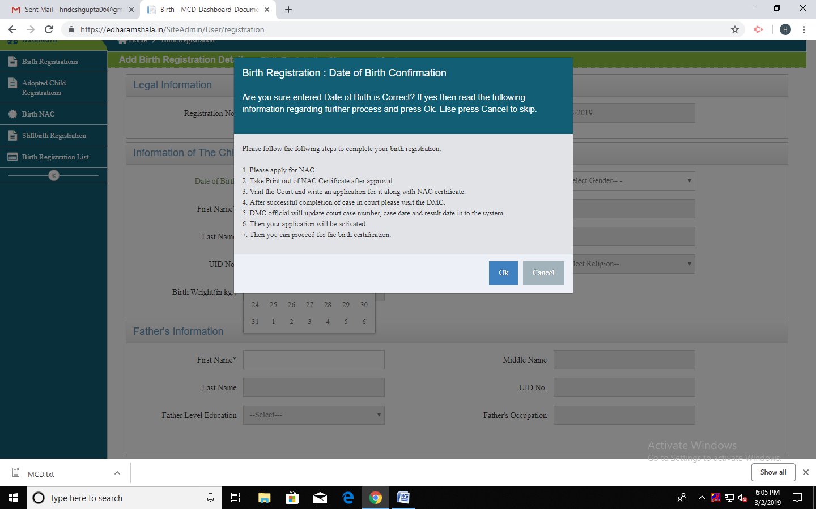

Necessary Documents of Birth
